SIRMA ACADEMY
Business Requirements
Gamification of the Learning Experience: Badges, Ranks & Progress Mechanics to Improve Course Completion and Learner Retention
Table of Contents
- Summary
- Context & Problem Statement
- Objectives
- Success Metrics (KPIs)
- Scope
- User Research: Designing for Player Motivation (Bartle's Taxonomy)
- Functional Requirements Overview
- Detailed Functional Requirements
- Proposed Badge Catalogue (Starter Set)
- Proposed Rank Ladder
- Data & Integration Approach (Non-Invasive Extension)
- Risks & Mitigations
- Phased Rollout Plan
- Acceptance Criteria (Given / When / Then)

1. Summary
Sirma Academy records learning activity with precision — enrolments, per-lesson completion, exam scores, and issued certificates are all captured in the platform's data model — but none of that data is surfaced back to the learner as motivation. Progress is tracked administratively, not experienced, so the completion funnel depends entirely on the learner's own discipline, with no in-product nudge to start the next lesson, return after a lapse, or finish a partially completed course.
This document proposes a “gamification” layer — points, badges, ranks, streaks, and leaderboards — built on top of existing enrolment, completion, certificate and program data. The design requires no change to the source files (User, Course, CourseInstance, Program, Seminar, SeminarInstance, Certificate); it is an additive extension that reads existing fields and writes to new, purpose-built collections. The feature set is derived using Bartle's player-type taxonomy (Achievers, Explorers, Socializers, Killers) so the mechanics motivate the whole learner base, not only the competitive minority, in service of a measurable goal: higher completion rates and stronger learner retention.
Bottom line for the business
Gamification is proposed not as a cosmetic add-on but as a retention lever attached directly to the two metrics the Academy is measured on: how many learners finish what they start, and how many come back for the next course.
2. Context & Problem Statement
The Academy platform already models the learner journey in reasonable depth:
- A User enrolls in CourseInstances, SeminarInstances, Assessments and Programs (enrolledCourseInstances, enrolledSeminarInstances, enrolledPrograms).
- Each CourseInstance breaks a course into a curriculum of lessons, and each lesson tracks who completed it (curriculum[].lessons[].completedBy).
- Completion is recorded at the User level (successfullyCompletedCourses) and the Course level (successfullyCompletedByUsers).
- A Certificate carries a numeric score (0–100) per completed CourseInstance — a ready-made measure of performance, not just attendance.
- A Program orders multiple Courses with prerequisites, and already exposes progress and "next course" logic (calculateProgress, getNextCourse).
The raw material for a motivation layer already exists — it is simply never presented back to the learner as feedback, achievement, or comparison. Three business risks follow:
- Mid-course drop-off: a learner on 2 of 8 lessons has no visible signal pulling them back to lesson 3.
- Weak retention: finishing a Course gives no in-product reason to start the next one in a Program.
- No recognition of excellence: a 95/100 and a 61/100 certificate look identical to the learner and to peers.
3. Objectives
The gamification module is designed against the following business objectives, ordered by priority:

ID | Objective | Primary Metric Affected
O1 | Increase the completion rate of enrolled Course Instances (fewer abandoned enrolments) | Course/Program completion rate
O2 | Increase learner retention — repeat logins and continued activity across a Program | 7/30-day active learner rate
O3 | Increase progression from one Course to the next within a Program | Program completion rate, re-enrolment rate
O4 | Encourage higher-quality effort, not just attendance (reward Certificate score, not only completion) | Average certificate score
O5 | Build an extensible achievement framework that future features (mobile app, new course types) can plug into without a redesign | Engineering delivery velocity for future gamified features
4. Success Metrics (KPIs)
Each KPI below should be captured for a baseline period before launch and tracked after launch to judge impact.
KPI | Baseline Source | Target Direction
Course completion rate (completed / enrolled CourseInstances) | CourseInstance.enrolledUsers vs. Course.successfullyCompletedByUsers  (CourseInstance.js and Course.js) | Increase
Program completion rate | Program.enrolledUsers vs. Program.completedByUsers(Program.js) | Increase
Lesson drop-off point (last completed lesson before inactivity) | curriculum[].lessons[].completedBy timestamps (CourseInstance.js) | Later in curriculum / reduced
Learner 30-day return rate | New: PointsLedger / activity log (Section 9) | Increase
Average certificate score | Certificate.score (Certificate.js) | Increase
% of eligible learners earning at least one badge in first 14 days | New: BadgeAward collection | High adoption (leading indicator)
Leaderboard opt-in / view rate | New: gamification engagement log | Track for engagement, not a hard target

5. Scope
- Points / experience (XP) system tied to existing learning events (lesson completion, course completion, certificate score, program completion).
- Badge catalogue and award engine (Section 10).
- Ranks / levels derived from accumulated points (Section 11).
- Learning streaks (consecutive days/weeks of activity).
- Leaderboards, respecting the existing User.private flag as an opt-out (Section 12).
- A learner-facing "Gamer Profile" surface showing points, rank, badges and progress.
6. User Research: Designing for Player Motivation (Bartle's Taxonomy)
A gamification layer that only rewards the top of a leaderboard motivates a small, already-competitive slice of learners and discourages everyone else. To design mechanics that lift completion and retention across the whole learner base, this BRD uses Richard Bartle's player-type model, shown below, which groups player motivation into four archetypes along two axes: acting vs. interacting, and world-focused vs. player-focused. Each learner is a mix of all four, so the feature set is deliberately built to give every type at least one mechanic that speaks to them.
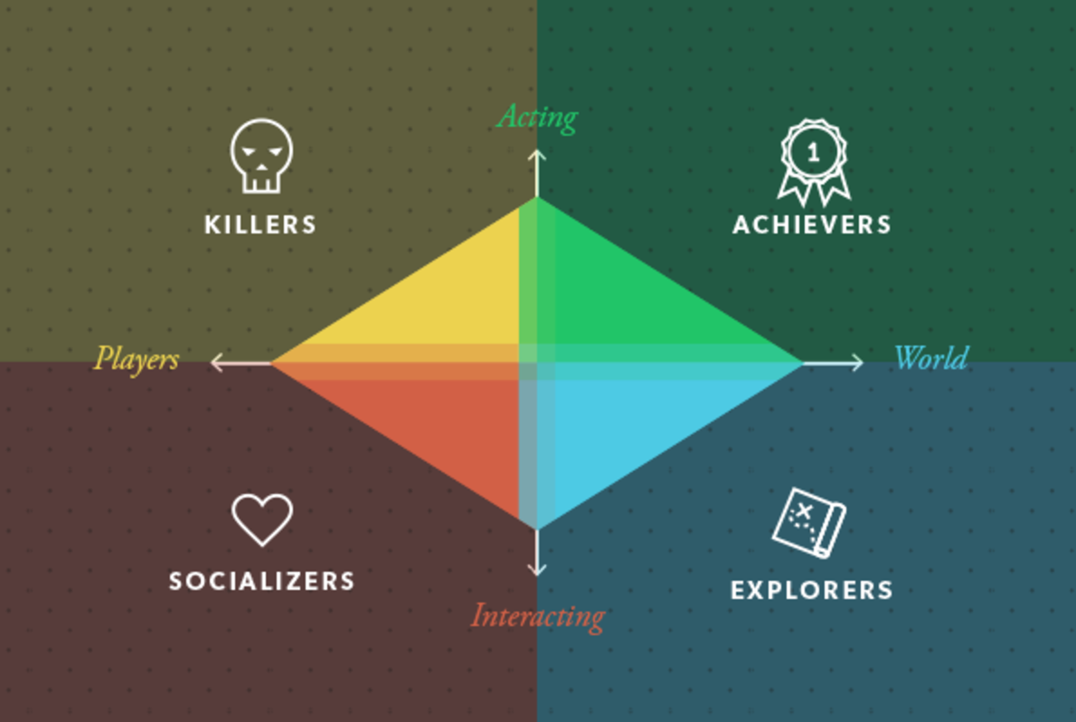
Figure 1 — Bartle's Player-Type Model, applied to the Academy learner base
Player Type | Motivated By | How This Shows Up in an Academy Learner | Mechanics Aimed at Them
Achievers | Status, completion, measurable progress | Wants to finish the course, get the certificate, see a checklist clear | Points/XP, progress bars, completion badges, certificate-tier badges (Proficient, Advanced, Flawless)
Explorers | Discovery, mastery of content, uncovering everything available | Reads every lesson resource, tries courses across different categories, revisits old material | Hidden/secret badges, "completionist" badges for 100% curriculum content, cross-category exploration badges
Socializers | Interaction with and recognition from peers/cohort | Values being seen by classmates in a live CourseInstance or SeminarInstance, likes group milestones | Cohort milestones, teacher endorsement badges, opt-in cohort leaderboards, "study group" streaks
Killers | Competition, comparison, being ranked above others | Wants to know their exam score relative to peers, enjoys being #1 | Global/course leaderboards, ranks with visible tiers, timed "speed-run" completion badges

7. Functional Requirements Overview
Each requirement is mapped to the existing schema field(s) that trigger it, so engineering can trace every mechanic back to a real, already-captured event — no new tracking has to be invented, only new reactions to existing writes.
ID | Requirement | Existing Data Trigger | Player Type(s) Served | Priority
FR-1 | Award XP for each completed lesson, course, and program | curriculum[].lessons[].completedBy; User.successfullyCompletedCourses; Program.completedByUsers | Achievers | Must
FR-2 | Award named badges for defined milestones | Same as FR-1, plus Certificate.score | Achievers, Explorers | Must
FR-3 | Derive a Rank/Level from cumulative XP | New: aggregate of FR-1 events | Achievers, Killers | Must
FR-4 | Track learning streaks (consecutive active days) | New: daily activity log derived from completedBy timestamps | Achievers, Socializers | Should
FR-5 | Course/global leaderboards, opt-in and privacy-aware | New: XP aggregate + User.private | Killers, Socializers | Should
FR-6 | Learner-facing Gamer Profile (points, rank, badge case, progress) | Aggregation of all of the above | All types | Must
FR-7 | Certificate-tier recognition (Proficient, Advanced, Flawless) | Certificate.score thresholds | Achievers | Must
FR-8 | Program milestone recognition (path completion, "next course" nudge) | Program.calculateProgress(), Program.getNextCourse() | Achievers, Explorers | Should
FR-9 | Cohort/teacher recognition badges | CourseInstance.teachers, enrolledUsers | Socializers | Could
FR-10 | Cross-category exploration badges | Course.category / subcategories across enrolments | Explorers | Could

8. Detailed Functional Requirements
FR-1 — Points / Experience (XP) System
Every learning event the platform already records, generates an XP award, logged individually so awards stay auditable and reversible if an event is later invalidated (e.g. an enrollment is cancelled).
Event (existing data) | Suggested XP
A lesson is marked completed (curriculum[].lessons[].completedBy entry added) | 10 XP
A full CourseInstance is completed (User.successfullyCompletedCourses updated) | 100 XP
A Certificate is issued (Certificate created) | 50 XP + bonus scaled by Certificate.score
A full Program is completed (Program.completedByUsers updated) | 500 XP
Attendance at a live SeminarInstance (enrolledUsers + session participation) | 25 XP
Acceptance criteria: Given a learner completes the final lesson of a CourseInstance, when the completedBy array update is persisted, then an XP award for both the lesson and the course-completion bonus is written to the new PointsLedger within the same request/transaction window, and the learner's aggregate GamificationProfile.totalPoints is updated.
FR-2 — Badges
A badge is a discrete, named recognition tied to a specific rule (full starter catalogue in Section 10). Badges are permanent once earned — a historical record, not a currency — and are stored against the learner with a reference back to the triggering event (e.g. the Certificate or CourseInstance) for traceability.
Acceptance criteria: Given a learner's Certificate.score is recorded as 92, when the badge-award engine evaluates certificate-tier rules, then a "Distinguished Graduate" badge is awarded exactly once and appears in the learner's badge case within the same session.
FR-3 — Ranks / Levels
Ranks are a small, human-readable ladder (Novice → Apprentice → Practitioner → Specialist → Master) derived from cumulative XP thresholds (Section 11), recalculated whenever XP changes and shown as the headline stat on the Gamer Profile.
FR-4 — Streaks
A streak counts consecutive active days (or weeks, for lighter usage patterns) on which the learner completed a lesson or attended a session — rewarding the habitual return visits that directly serve objective O2, with a "don't break the chain" indicator on the Gamer Profile. Streak logic reuses the same completedBy / enrolledUsers timestamps the platform already writes; no new client-side tracking is required.
FR-5 — Leaderboards
Leaderboards are scoped, not global-only, to avoid the Killer-mechanic risk noted in Section 7:
- Course-cohort leaderboard: ranks learners within the same CourseInstance.enrolledUsers list — a small, relevant peer group.
- Program leaderboard: ranks learners progressing through the same Program.
- Academy-wide leaderboard: opt-in only, and always excludes any User with private: true (an existing field on the User model — this requirement reuses it rather than introducing a new privacy flag).
Acceptance criteria: Given a User document has private set to true, when any leaderboard is rendered, then that learner is excluded from all leaderboard views regardless of their XP or rank.
FR-6 — Gamer Profile
A single learner-facing screen that aggregates current rank and XP-to-next-rank, badge case, active streak, and — for Program-enrolled learners — a progress bar reusing Program.calculateProgress() and a "what's next" prompt reusing Program.getNextCourse().
FR-7 — Certificate-Tier Recognition
Certificate.score range | Tier badge
0–59 (below existing pass threshold, if any) | No tier badge — completion badge only
60–79 | Proficient
80–92 | Advanced
93–100 | Flawless
Exact thresholds should be confirmed with the Academy/Content team against whatever pass mark the Assessment model already enforces; the ranges above are a starting proposal, not a final cut.
FR-8 — Program Milestones
When Program.calculateProgress() crosses 25%, 50%, 75% and 100% for a learner, a milestone badge and XP bonus are issued; at 100% the learner is added to Program.completedByUsers as already happens today — the gamification layer only listens for that write, it does not change it.
FR-9 — Cohort & Teacher Recognition (Should/Could)
Where a CourseInstance has assigned teachers (User.teacherInfo), a lightweight endorsement action lets a teacher flag a standout cohort learner for a "Mentor's Pick" badge — a low-effort Socializer mechanic for teachers to recognise effort.
FR-10 — Cross-Category Exploration (Could)
A learner completing CourseInstances whose parent Course.category spans three or more distinct categories earns an "Explorer" badge — rewarding breadth of engagement and supporting cross-sell into new categories.
9. Proposed Badge Catalogue (Starter Set)
A starting catalogue of 12 badges is proposed for launch, deliberately spread across all four Bartle types so no single motivation style is left unserved.
Badge (EN) | Trigger Rule | Player Type
First Step | First lesson ever completed | Achiever
Course Conqueror | First full CourseInstance completed | Achiever
Program Pioneer | First full Program completed | Achiever
Distinguished Graduate | Certificate.score ≥ 93 | Achiever
Perfectionist | Certificate.score = 100 | Achiever
Completionist | 100% of a curriculum's lessonContent viewed, not just marked complete | Explorer
Explorer | Courses completed across 3+ distinct categories | Explorer
Night Owl / Early Bird | Pattern of lesson completions outside standard hours | Explorer
On a Roll | 7-day activity streak | Achiever / Socializer
Marathoner | 30-day activity streak | Achiever / Socializer
Mentor's Pick | Teacher-endorsed standout learner in a cohort | Socializer
Top of Class | #1 on a course-cohort leaderboard at course end | Killer
10. Proposed Rank Ladder
Ranks give Killers and Achievers a single, always-visible number to chase, and give Marketing a simple vocabulary for retention campaigns ("you're one course away from Practitioner"). XP thresholds below are an illustrative starting point for Product/Data to tune post-launch.
Rank | XP Threshold | Indicative Meaning
Novice | 0 | Just enrolled — default starting rank
Apprentice | 150 | Completed first course or several lessons
Practitioner | 500 | Multiple courses completed, consistent activity
Specialist | 1,200 | Program completion or high-scoring certificates
Master | 2,500+ | Sustained, high-performing engagement across multiple Programs
11. Data & Integration Approach (Non-Invasive Extension)
The seven schema files provided are treated as frozen for this engagement. Rather than adding gamification fields onto them, this BRD proposes new, additive collections that reference the existing models by ObjectId — keeping the module cleanly separable, testable and reversible, with no risk to existing enrolment, grading or certificate logic.
New Collection | Purpose | Reads From (existing, unaltered)
GamificationProfile | Per-user aggregate: totalPoints, currentRank, currentStreak, longestStreak, lastActiveAt | User._id
PointsLedger | Append-only, auditable log of every XP award (one row per event) — enables recalculation and dispute resolution | User._id, CourseInstance._id, Course._id, Program._id, Certificate._id
Badge | Static catalogue of badge definitions (name/nameBg, rule, icon, player type) | No dependency
BadgeAward | Join record: which User earned which Badge, when, and the source document that triggered it | User._id, Badge._id, plus the triggering Course/CourseInstance/Certificate/Program _id
LeaderboardSnapshot (optional, for performance) | Periodically cached ranking per CourseInstance/Program/Academy-wide scope, to avoid recomputing rankings on every page view | GamificationProfile, User.private
Integration is event-driven at the application-service layer: wherever the existing codebase already writes to completedBy, successfullyCompletedCourses, Certificate, or Program.completedByUsers, a gamification hook fires after that write succeeds. No existing write path is modified, and the hook fails closed — a gamification error never blocks or rolls back the underlying academic operation.

12. Risks & Mitigations
Risk | Mitigation
Leaderboards demotivate slower learners (Killer mechanic overused) | Default to cohort-scoped, opt-in boards; use percentile/tier framing rather than raw rank Academy-wide (FR-5)
Badge/points inflation devalues the system over time | Keep the starter catalogue small (12 badges) and data-driven so thresholds can be retuned without a release
Learners game the system for XP (e.g. rapid, low-effort clicking) | Award XP only on events the platform already trusts (completedBy, Certificate issuance), never on raw click-through
Added write load on every completion event | Gamification hooks run after the primary transaction and fail closed, so peak load never affects core flows
Privacy complaints over unexpectedly visible rank/activity | Leaderboard exclusion via the existing private flag is a hard requirement, tested in acceptance criteria (FR-5)
13. Phased Rollout Plan
Phase | Scope | Rationale
Phase 1 | FR-1 (XP), FR-2 (Badges — core 6), FR-6 (Gamer Profile), FR-7 (Certificate tiers) | Delivers the Achiever-facing core with the least engineering risk and no leaderboard/privacy complexity; validates KPI tracking pipeline first
Phase 2 | FR-3 (Ranks), FR-4 (Streaks), FR-8 (Program milestones), remaining badges | Adds the retention-oriented mechanics (ranks, streaks) once the core award pipeline is proven stable
Phase 3 | FR-5 (Leaderboards), FR-9 (Teacher endorsement), FR-10 (Exploration badges) | Adds Socializer/Killer mechanics last, once privacy exclusion and cohort scoping can be properly tested against real usage data from Phases 1–2
14. Sample Acceptance Criteria (Given / When / Then)
- Given a learner completes the last lesson in a CourseInstance's curriculum, when the completedBy write for that lesson succeeds, then the platform awards lesson XP, course-completion XP, evaluates badge rules, and updates GamificationProfile.totalPoints — all without altering the existing completion write itself.
- Given a Certificate is created with score = 96, when the badge engine runs, then a "Distinguished Graduate" and "Perfectionist"-adjacent tier badge (per the thresholds in Section 9, FR-7) is recorded in BadgeAward exactly once.
- Given a User has private = true, when any leaderboard (course, program, or Academy-wide) is requested, then that user never appears in the returned rankings, even if their own profile still shows their personal rank and XP.
- Given Program.calculateProgress() returns 100 for a learner, when the gamification hook evaluates Program milestones, then a completion badge and the corresponding XP bonus are awarded exactly once, with no duplicate award on subsequent recalculation.

